|  |  |
| --- | --- |
| **Name** | **SHAFKAT AHMAD KHANDI** |
| **Designation** | Associate Professor |
| **Contact Address** | Division of Veterinary & Animal Husbandry Extension Education,  Faculty of Veterinary Sciences & A.H., R. S. Pura, SKUAST-J, Jammu & Kashmir - 181102 |
| **E -mail** | shafkatext@gmail.com |
| **Mobile** | 7006063441 |
| **Professional Experience** | 15 years (Teaching, Research and Extension)  (One year and one month as Guest Lecturer/Teaching Assistant) |
| **PG students Guided** | ***Major Advisor:***   * Ph.D: **01** * M.V.Sc: **07**   ***Co-Advisor:***   * Ph.D: **04** * M.V.Sc: **20** |
| **Awards/honours/**  **scholarships/fellowships** | **International:**   * **International Fellowship Award by the Government of Netherlands** * **Best Oral Presentation Award at International Buffalo Congress-2019 held at University of Veterinary & Animal Sciences, Lahore-Pakistan** * Attended an International training programme on **“Training & Extension”** organized by the Government of Netherland w.e.f 05.06.2019 to 06.07.2019.   **National :**   * Remained **Head of the Division** two times * University Merit Scholarship holder at M.V.Sc Level (Scholastic Standards of High order) **(Topper).** * University Merit Scholarship holder at Ph.D Level (Scholastic Standards of High Order). * Budding Extensionst Award-2015 * Farmer Lead Extension Award-2017 * Best Extension Scientist Award-2023 * Best Paper/Poster Presentation Awards: **12** No.s |
| **Publications** | More Than **60** Research Articles |
| **No. of books/Manuals/**  **Monographs** | Books: **01**  Contributory chapters : **10**  Manuals: **04**  Monographs: **20** |
| **Research Projects** | ***Project Investigator:***   * DST: **01** * University funded: **01**   ***Co-Project Investigator:***   * Externally funded: **06 (04 Completed & 02 Ongoing)** * University funded: **02 (Completed**) |
| **Research interests** | * Pastoral/tribal livestock production systems * Perception in cellular agriculture- cultivated meat * Socio-economic impact of lumpy skin disease * Perception about edible insects as a source of protein * Precision farming/ smart livestock farming * Adoption and diffusion of scientific animal husbandry practices * Ethno-veterinary and indigenous technical knowledge |
| Other achievements | * Represented the State in 10th National Chess Championship held at Jamshedpur. * Represented the State in TATA STEEL 38th National ‘B’ Chess Championship held at Jamshedpur. * Represented the State in 45th Junior National Ball Badminton Championship held at Jaipur, Rajasthan. * Represented the State in 46th Junior National Ball Badminton Championship held at Bhilai, M.P. * Represented the SKUAST-J in two events (Volley Ball and 100m Running) at Inter-university Competitions held at Parbhani, Maharashtra. * Represented the SKUAST-J in Volley Ball at Inter-university Competitions held at Bareily, U.P. |

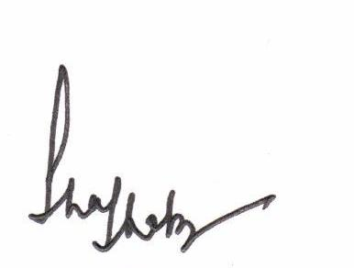

(**Shafkat Ahmad Khandi**)